IT520 LAB 7

Chibunze Uzo

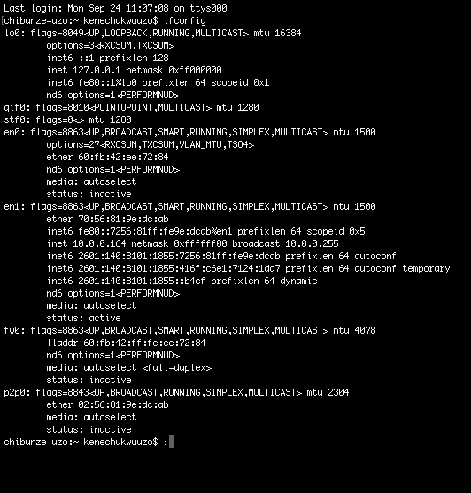

1. An SSID is a one or two word identifiers of the access point. In this case, Cisco-Li’s SSID is 30 Munroe St, and LinksysG_67:22:94’s SSID is linksys 12.

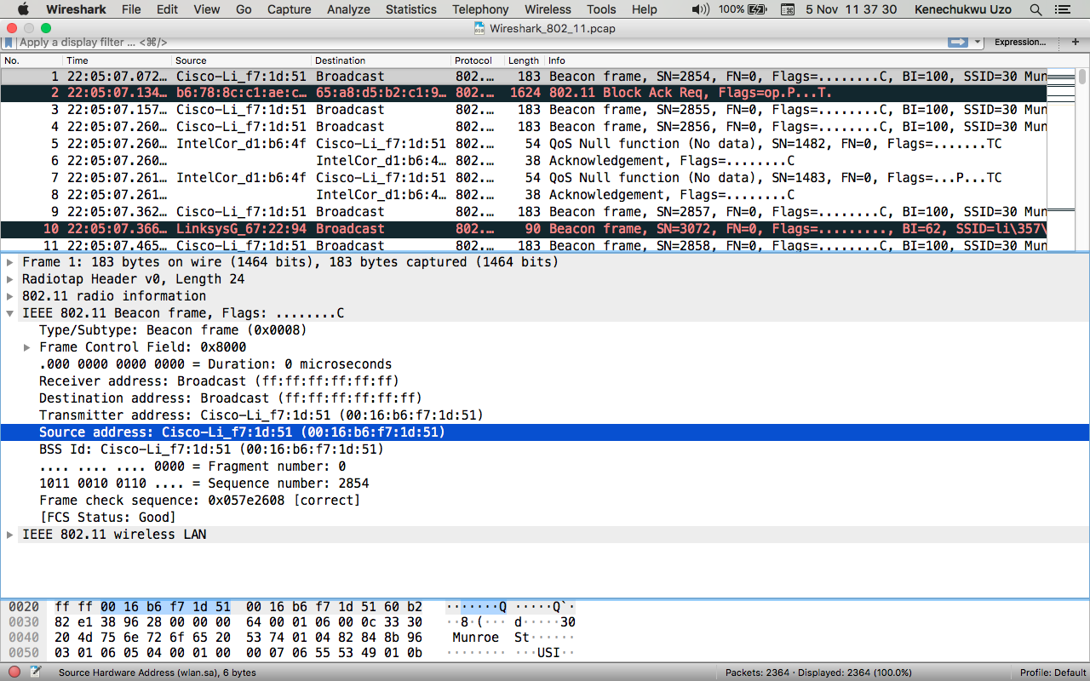

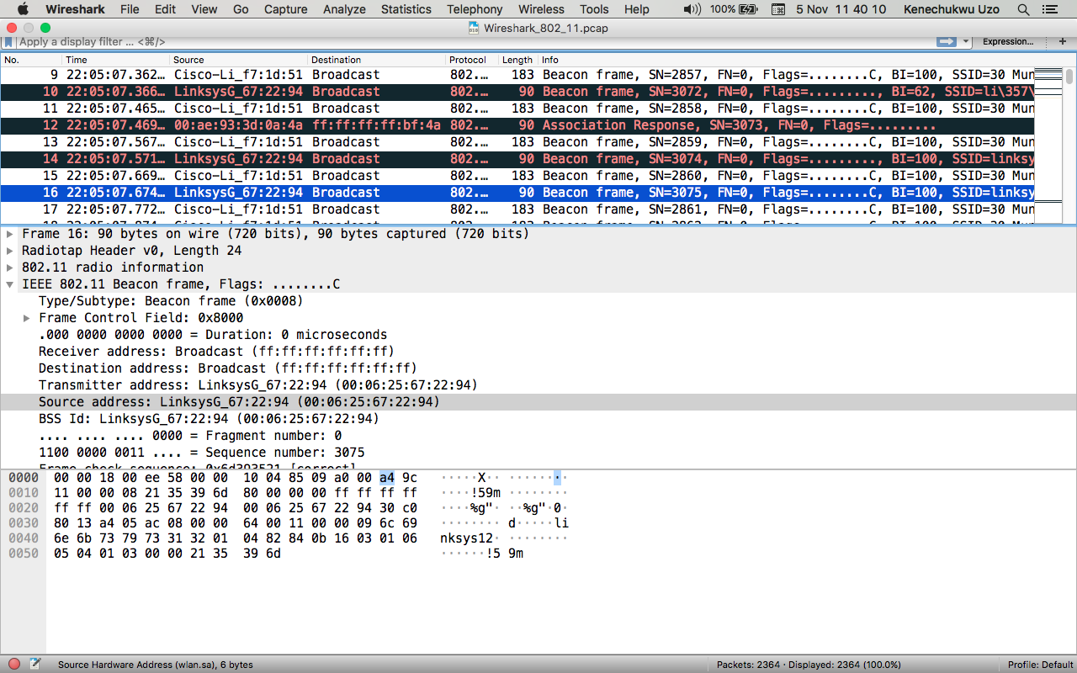

2. 0.102400 seconds

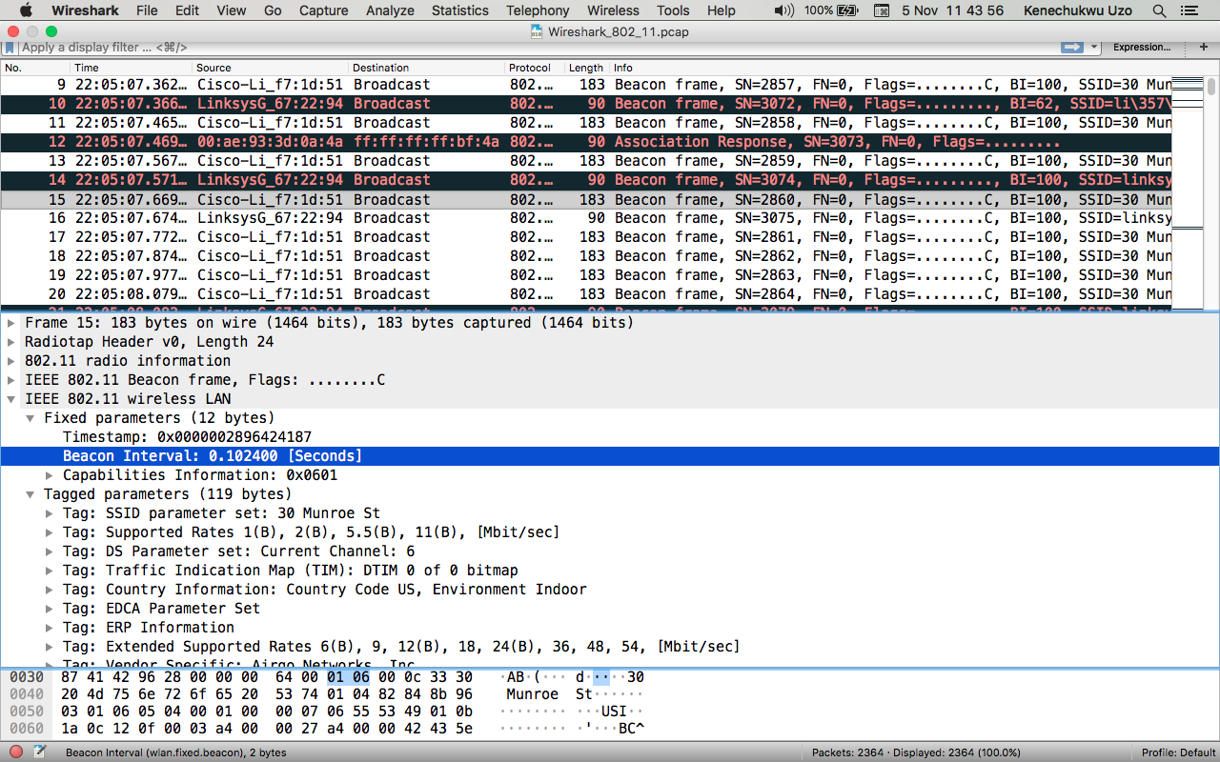

3. Source MAC address on the beacon frame from 30 Munroe St is 00:16:b6:f7:1d:51

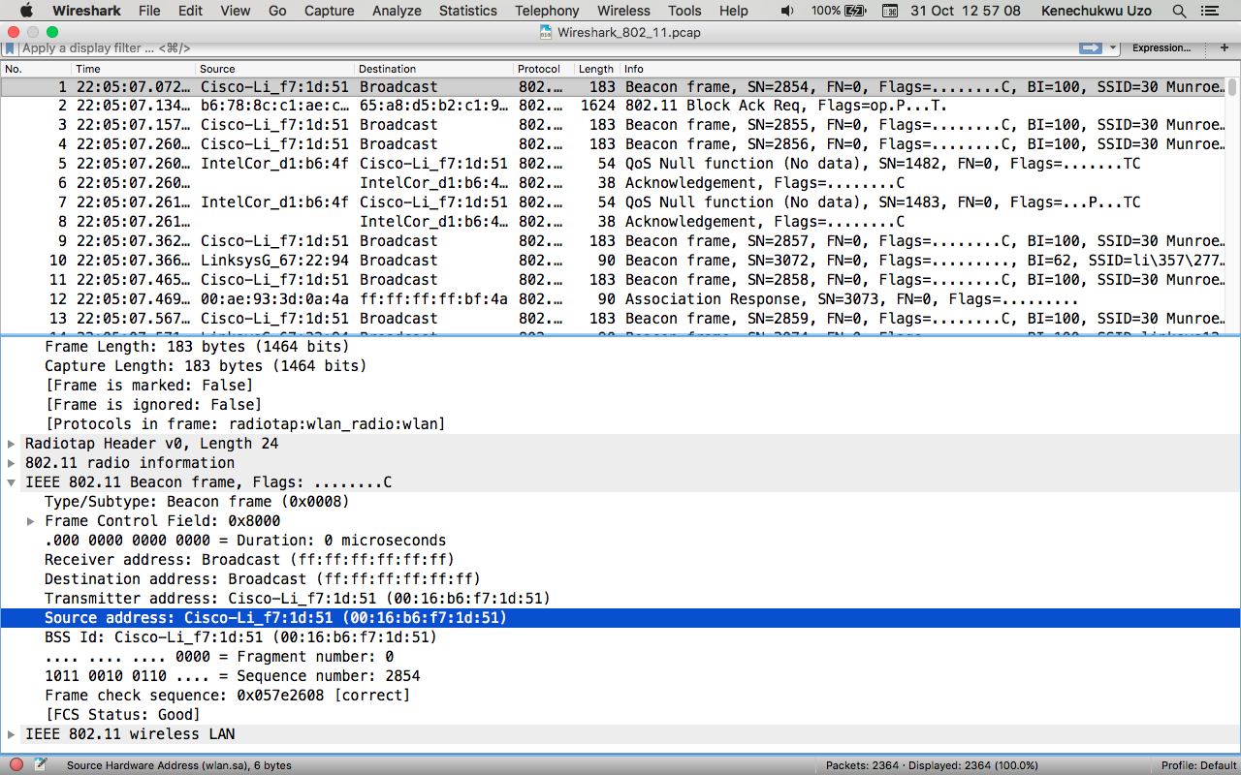

4. Destination MAC address on the beacon frame from 30 Munroe St is ff:ff:ff:ff:ff:ff

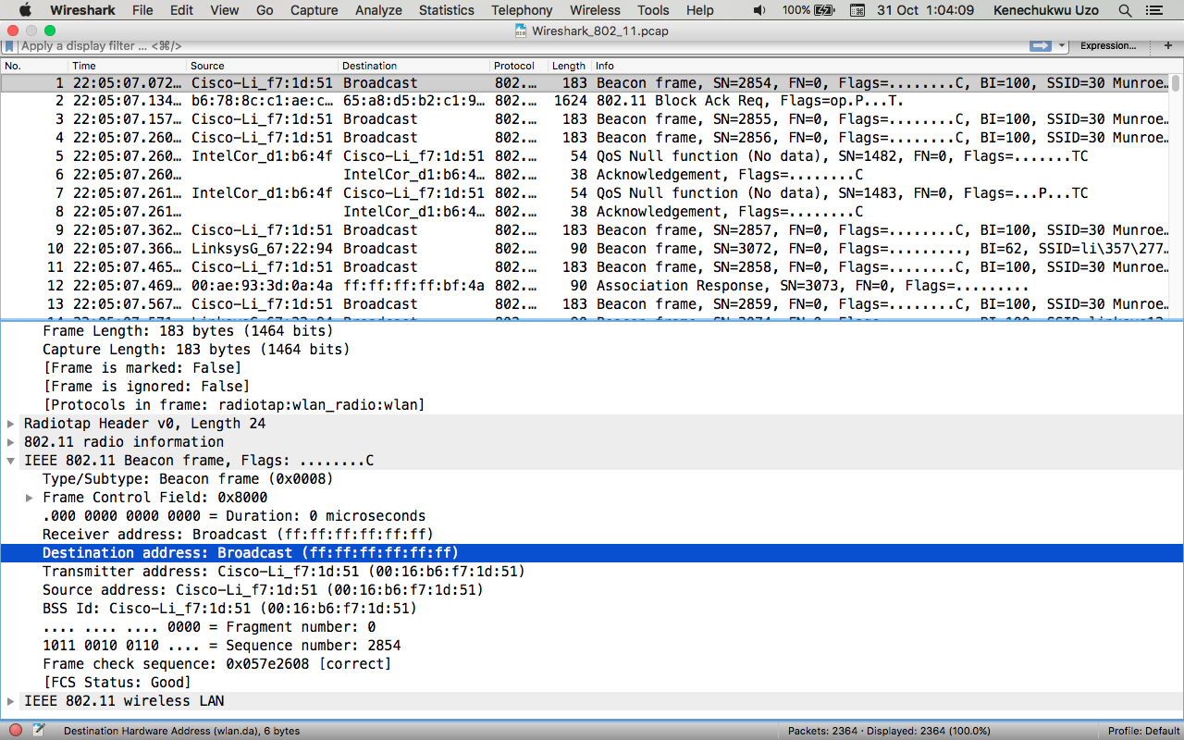

5. The BSS Id for 30 Munroe is Cisco-Li_f7:1d:51 ( 00:16:6b:f7:1d:51)

